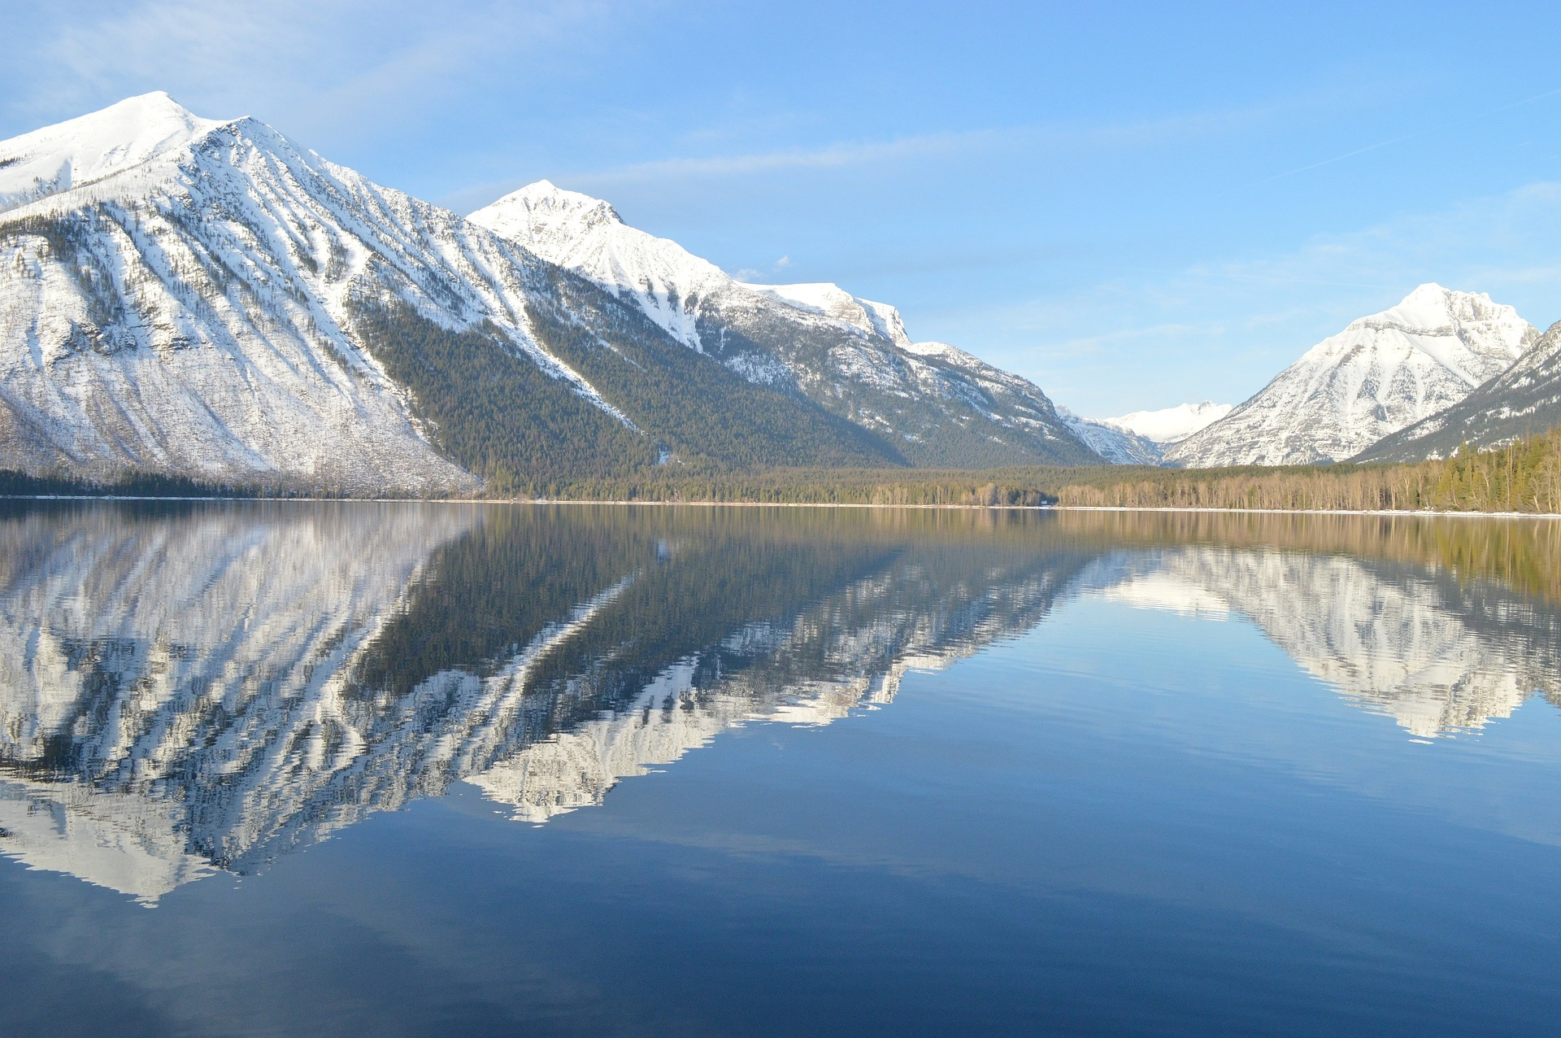

**Source is fictional**

Page number

Author’s name

Glacier National Park may not be the most well-known or widely visited National Park in the United States, but it boasts wonders of nature comparable to anything you can see at Yellowstone or Yosemite. Glacier covers over one million acres of Montana wilderness that includes mountain ranges, hundreds of lakes, and a vast array of plant and animal species. Its glories are too many

Article title

*Lake McDonald, largest lake in Glacier National Park*

*World Traveler*

to count in such a short profile, but three worth noting are Lake McDonald, Chief Mountain, and Bird Woman Falls.

Stretching out like a mirror along the mighty Rocky Mountains, the ten-mile long Lake McDonald may be the perfect reflection of the grandeur of Glacier National Park. Formed by the park’s namesakes, the lake is

*Terrence Trent*

The Glories of Glacier National Park

18

17

16